**Bookly App Report**

**App Description**

Bookly is a mobile application designed to help users discover, track, and review books, among other functions. The app is aimed at book lovers, whether new to reading ebooks or novices. The app provides a personalized reading experience with unique features such as book quizzes, popular book recommendations, common quotes, and progress tracking. The interface is designed to be minimalistic and user-friendly, focusing on retro muted color tones and geometric shapes that are easy on the eyes and inviting.

**Screen Description and Transitions**

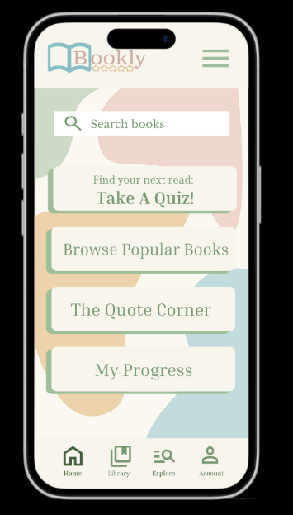The **home screen** features a user-friendly design with a menu conveniently located in the top-right corner and a search bar prominently positioned in the top-center. The search bar allows users to find specific books by title or author. The main section of the screen includes four buttons, each showcasing potential additional features (Note: for this project, these buttons are non-interactive and serve as visual representations of functionality we could implement in the future):

1. *Take a Quiz*: Helps users discover genres or book tropes they might enjoy based on their preferences.
2. *Browse Popular Books*: Showcases trending and popular book recommendations for readers seeking something new.
3. *The Quote Corner*: Provides a collection of daily quotes from books and highlights quotes recently appreciated by other users.
4. *Your Progress*: Displays a personalized overview of the reader's journey, including previously read books and total reading time.

This intuitive layout ensures an engaging and seamless experience for book lovers. The bottom portion of the screen features a navigation ribbon with icons for “My Library,” “Discover Books,” “Account,” and “Home.” Selecting the menu icon triggers an instant transition to the menu screen, while each ribbon icon transitions seamlessly to its respective screen, enhancing user accessibility and navigation.

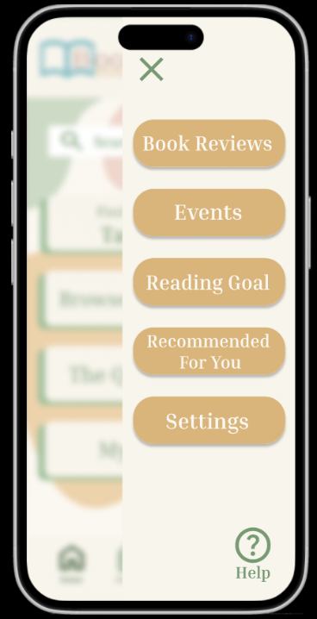The **Menu** screen applies a blur effect to the background and introduces a sidebar with various options, including:

1. *Book Reviews*: A section to view and manage personal reviews.
2. *Events*: Information about book-related events happening nearby.
3. *Reading Goal*: Displays the user’s current reading goal, books completed for the year, and progress from previous years.
4. *Recommended For You*: Personalized suggestions for the user’s next read.
5. *Settings*: Access to adjust app preferences and configurations.

In the bottom-right corner, a Help icon provides quick assistance for navigation or general app questions. The Close icon at the top enables a smooth transition back to the Home screen. Additionally, the menu icons darken to indicate the currently active screen. (Note: For this project, these buttons are non-interactive and serve as visual placeholders for potential future functionality.)

The **Library** screen features a baby blue color scheme with a search bar positioned at the top-center of the screen. The central section includes a display box for the current book the user is reading.

Below this, two lists categorize the user’s books:

1. *Next Books*: A list of books the user plans to read, represented with a "+50" placeholder to signify the number of books.
2. *Finished Books*: A collection of books the user has completed, marked with a "+10" placeholder.

Clicking these placeholders will show the full list of books in each category.

The ribbon at the bottom retains the same navigation icons as other screens. Additionally, the Library screen includes a Yearly Book Goal Progress bar, visually indicating the percentage of the user’s progress toward their annual reading goal. Transitions for this screen include seamless navigation to the Home and Explore screens.

The **Explore** screen, styled with a pink color scheme, is designed to help users discover their next great read. The screen is headed by the phrase “Discover Your Next Read”

At the top, a search bar enables book discovery by keywords. The center section contains scrollable categories featuring curated book collections:

1. *New Releases*: Books published within the current year.
2. *Because You Read…*: Personalized recommendations based on books the user has read and logged in the app.
3. *Top Reads of This Year*: Displays the year’s most popular books, including ratings.
4. *Continue a Series*: Highlights unread books from series the user has started but not finished.

At the bottom, a “Search by Genre” button allows users to explore books by genre. The navigation ribbon is also present for quick access to other screens.

Transitions for this screen include navigation to the Home and Library screens. Below is a screenshot of the transitions.

**Colors and Icons**

We designed a palette of retro muted colors to create a visually appealing and comfortable user experience. The color scheme includes:

* *Sage Green*: Used for the Home page and navigation.
* *Light and Deep Shades of Yellow*: Featured in the background and menu buttons.
* *Baby Blue*: Applied to the Library screen.
* *Soft Pinks*: Highlighting the Explore screen.

These colors were carefully chosen to create a soft, inviting aesthetic that is easy on the eyes. The palette incorporates a level of transparency, blending seamlessly into the background and allowing menu icons and text to stand out more prominently. With a total of seven colors, the scheme ensures good contrast between text and background, avoiding accessibility issues.

The icons used throughout the app are consistent in design, alignment, clarity, and readability, all sourced from Google Icons for uniformity. This consistency enhances usability by making the icons intuitive and easily recognizable, reducing any confusion about their functions. Each icon is accompanied by a brief description to further assist users, ensuring clarity. Additionally, the icons are appropriately sized—not too small—providing excellent readability and ease of use. This thoughtful design approach prioritizes both aesthetics and functionality, delivering a cohesive and user-friendly experience.

**Buttons**

The buttons in the app are primarily rectangular, with some featuring rounded corners for a softer look. Button styles remain consistent across screens, maintaining a uniform design based on the context of each page. To ensure a clean and user-friendly interface, the app uses a minimal number of buttons, preventing the user from feeling overwhelmed with options.

Certain buttons incorporate a shadow effect, adding depth and enhancing the retro aesthetic. This effect is applied selectively, typically on screens with fewer buttons, to maintain visual balance and focus.

The buttons are also strategically placed to optimize usability, making the app easy to navigate with one hand. For instance, the menu icon is positioned on the right-hand side, while the navigation ribbon is located at the bottom of the screen. This thoughtful layout ensures that key actions are always within easy reach, enhancing both accessibility and user convenience.

**Menu Design**

The menu design is a pop-up sidebar that blurs the background. It is a design most often used in an application interface which makes it more familiar to users. The design is very simple, and the colors are changed to show a distinction in the screen. This allows for easy access to settings, help, and other options. The menu screen also has an exit button to return to the previous screen, so the user does not feel trapped within the screen. The bottom ribbon is another menu option design as it is persistent in all screens at the bottom of the screen. This allows for convenient quick access to the main sections of the app that the user will most frequently visit.

**Mobile App Design Guidelines**

The app maintains consistent design elements across all screens, ensuring a cohesive and polished user experience. Touch targets are large enough to enable easy tapping, reducing errors and enhancing usability. The navigation paths are clear and intuitive, allowing users to move seamlessly between screens. Additionally, the high-contrast color palette and readable Serif fonts—often set to bold or a darker hue of sage green—enhance accessibility and legibility. The font size is appropriately sized at over 11 points, ensuring a comfortable reading experience.

The app’s simplistic design focuses the user’s attention on its core functions. Its layout ensures that navigation is intuitive, making it simple to transition from one screen to another.

The design also incorporates ample space and padding between text, icons, and buttons, preventing overlap and minimizing the likelihood of accidental touches. The tab bars are kept clean and straightforward, with limited decorative elements. Each tab is clearly labeled without icons, providing clarity and avoiding confusion.

Given the app’s minimal navigation options, a navigation bar at the bottom of the screen was chosen for better usability, keeping all options visible at once. The search bar is prominently displayed with a magnifying glass icon and placeholder text, making it highly visible and easy to find. This thoughtful placement ensures it isn’t lost in the background, further enhancing user experience.

**Expectations for Response Time and Errors**

The ideal response time is under one second for most interactions to ensure a smooth user experience (instant), which is the setting for the transitions for this app. If the user is left waiting more time than expected they could feel discouraged from using the app or certain functions of the app or become frustrated with the interface. To enhance the UX for faster response times I could use loading indicators so that I can get pre-fetched data to minimize perceived wait times.

Errors that can be anticipated are network issues or invalid inputs. This can include when trying to log-in to their account or when typing the wrong book or author in the search bar, among other things. The errors can be handled by providing clear error messages that pop up or alert the user as the mistake is being made in red font so that they know what the issue is and how to resolve it. Some example error messages could be “Unable to connect. Please check your internet connection and try again.” Or “Input not recognized, please enter a valid search item.”